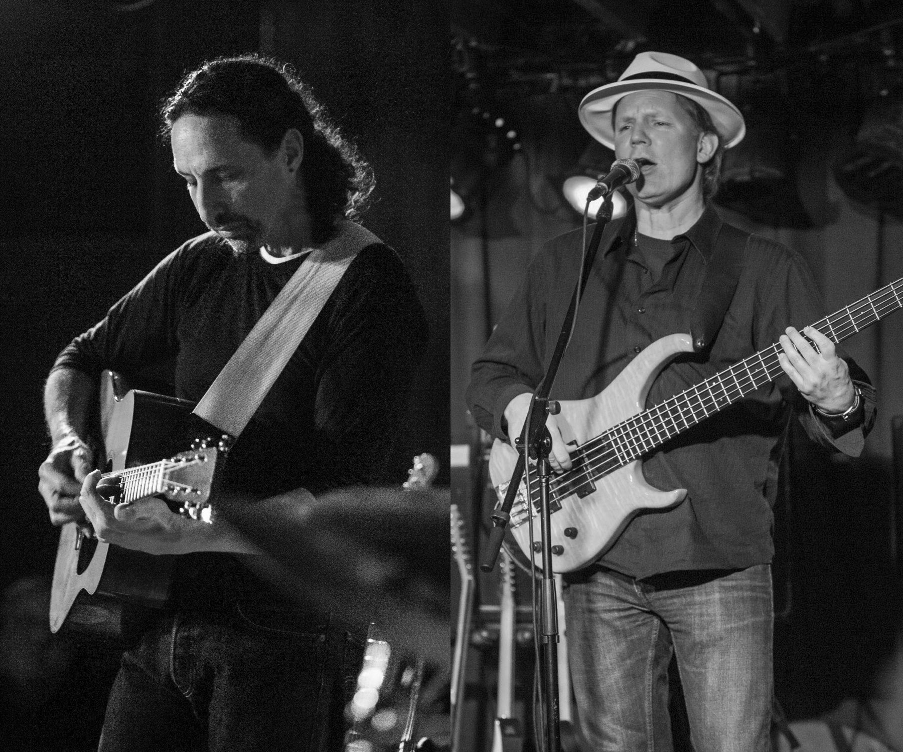
Gordon Whitlow
Acoustic Guitar, Bass & Vocals
Acoustic Rock
When & Where

